Research on Similar Systems

# Goat App

1. UI of app is very basic with not much creativity it’s just an app for a user to scroll and look at sneakers. You can tell the were looking for a minimalistic as possible.
2. App host a range products not only limited to sneakers but has the ability for user to shop the latest fashions as well.
3. App allows user to be able to look at latest fashion news as well which is an outstanding features so that users are aware of current trends.
4. Users
   1. Have the ability to access via Web and mobile apps
   2. Must have a profile with active payment information to purchase sneakers
   3. Have the ability to search for sneakers by name
   4. Can filter sneakers by year, brand, and gender
   5. Have the ability to make bids on as many sneakers as they would like but bid only last for a set time frame

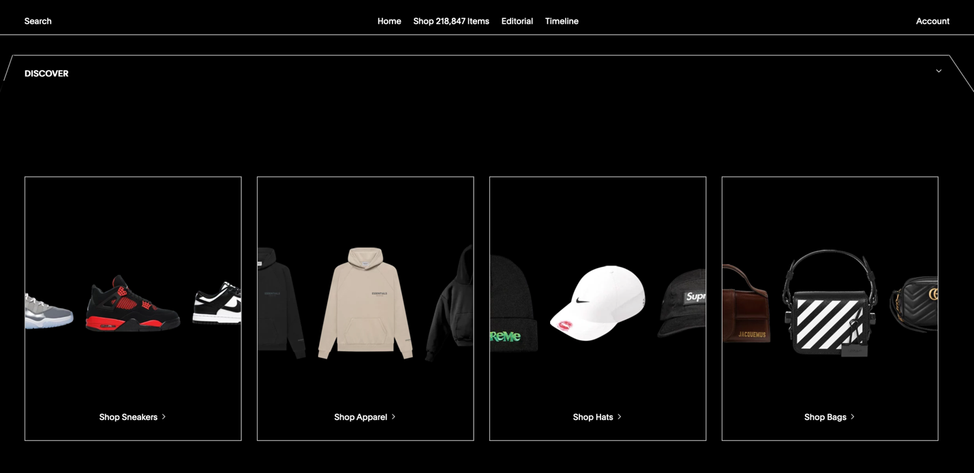

# Stockx App

1. UI of app is very modern with a lot creativity and great flow to it. They obviously cared about the user having a great experience while using the app.
2. App host a range products not only limited to sneakers but has the ability for user to shop the latest fashions as well.
3. App allows user to be able to look at latest fashion news as well which is an outstanding features so that users are aware of current trends.
4. Users
   1. Have the ability to access via Web and mobile apps
   2. Must have a profile with active payment information to purchase sneakers
   3. Have the ability to search for sneakers by name
   4. Can filter sneakers by year, brand, and gender
   5. Have the ability to make bids on as many sneakers as they would like but bid only last for a set time frame

